Tanja Poppelreuter
Mart Stam
Mart (Martinus Adrianus) Stam (1899 in Purmerend, Netherlands – 1986 in Goldach, Switzerland) was a Dutch architect, designer, and architectural theorist and was involved in a number of principal events and organisations during the 1920s and 1930s.
Stam moved to Berlin in 1922 to work as a draughtsman with Max Taut and Hans Poelzig among others. While in Berlin, Stam met El Lissitzky who introduced him to constructivism. Inspired by the progressive and social outlook of this Russian movement Stam founded the avant-garde magazine ABC. Beiträge zum Neuen Bauen [ABC. Contributions on Building] together with Hans Schmidt and Emil Roth (1924-1928). The magazine focussed on convincing readers about the social necessity for low-cost, well-designed, and functional houses as well as the use of modern technologies. ABC furthermore established connections to Asnova the association of new architects in Moscow, and published student work of Vkhutemas [School of Modern Architecture] in Moscow.
In 1927 Stam contributed to the exhibition Die Wohnung [The Dwelling] in Stuttgart with the design of a row house [Fig. 1]. The exhibition was organized by Ludwig Mies van der Rohe and the Deutsche Werkbund to showcase developments of functionalist and ‘objective’ architecture and was influential in the dissemination of ideas about modern design and architecture. In his design, Stam was interested in the development of mass-housing types for working-class dwellers.
For his house in Stuttgart, Stam also designed a cantilevered tubular steel chair – his best-known design [Fig. 2]. The novelty of the chair was in the idea of a seat without back legs for support. As a proponent of functionalism Stam sought to overcome predetermined designs and shapes and rejected notions of beauty through symmetry, or the use of ornament for symbolic and representational ends. Designers like Stam developed objects by analysing their use andby incorporating mass-producible materials to arrive at a prototype for mass-production, instead of at a handcrafted and unique item.
In 1928 Stam was among the founding members of the CIAM (Congrès internationaux d'architecture moderne) that provided an international platform for the various members and theoretical outlooks of the early 20th-century modern movement.
In 1928/29, Stam taught as a guest lecturer for urban planning at the Bauhaus in Dessau and also began working at Frankfurt am Main. Here, the German architect Ernst May pursued under the title Das Neue Frankfurt [The New Frankfurt] a citywide housing programme for working-class dwellers in an effort to establish better living conditions through standardised housing types. Stam was involved in the settlement Hellerhof (1929) [Fig. 3] and the Henry and Emma Budge Foundation Old People’s Home (1929-1930). He furthermore joined May when he was invited to the USSR to work on city planning and standard designs for housing and communal living. (1930) [Fig. 4].
Stam’s most acclaimed work during the 1930s is the Drive-in Flats (1936) in Amsterdam. For five years after World War II Stam taught at several institutions in the German Democratic Republic (1948-1953) but he did not regain his pre-war influence in later years.
Word count: 497

Writings:
Numerous contributions to the magazines ABC. Beiträge zum Neuen Bauen and De 8 en Opbouw
References and further readings:
Ingberman, S. (1994) ABC. International Constructivist Architecture 1922-1939, Cambridge, London: MIT Press.
Máčel, O. (1990) ‘Avant-Garde Design and the Law: Litigation over the Cantilever Chair’, Journal of Design History 3 (2/3): 125-143.
Möller, W. (1997) Mart Stam (1899-1989) Architekt Visionär Gestalter. Sein Weg zum Erfolg 1919-1930, Tübingen: Ernst Wasmuth.
Rümmele, S. (1991) Mart Stam, Zürich: Artemis und Winkler.
Stam, M, and R. Blijstra (1970) Mart Stam: Documentation of His Work 1920-1965. English language ed. London: RIBA Publications.
The estate of Mart Stam is held at the Deutsche Architekturmuseum, Frankfurt am Main.
Paratextual Material:
Contemporary Photographs of the Hellerhof Estate by Matthias Matzak (accessed Dec. 16, 2012) http://neues-frankfurt.matzak.de/hellerhof/content/index.html
Contemporary Photographs of the Henry and Emma Budge Old Peoples Home by Matthias Matzak (accessed Dec. 16, 2012)
http://neues-frankfurt.matzak.de/budgeheim/content/index.html
A new way of building in Frankfurt – 1982. Neues Bauen in Frankfurt am Main. A film in four parts directed by Paul Wolff, subjects by Ernst May, 16 mm, b/w, mute with subtitles, length of the four films: 6', 8', 10 'and 10', produced by 'Wolff-Film' (accessed Dec. 16, 2012)
http://www.planum.net/neues-bauen-in-frankfurt-am-main-a-new-way-of-building-in-frankfurt
Johannes Brinckman with L. C. van der Vlught and Mart Stam, Van Nelle Factory, 1926-1930 (accessed Dec. 16, 2012) Van Nelle Fabriek vroeger (Dutch) 3:59
http://www.youtube.com/watch?v=Wp3bwsd5ntw
Images:
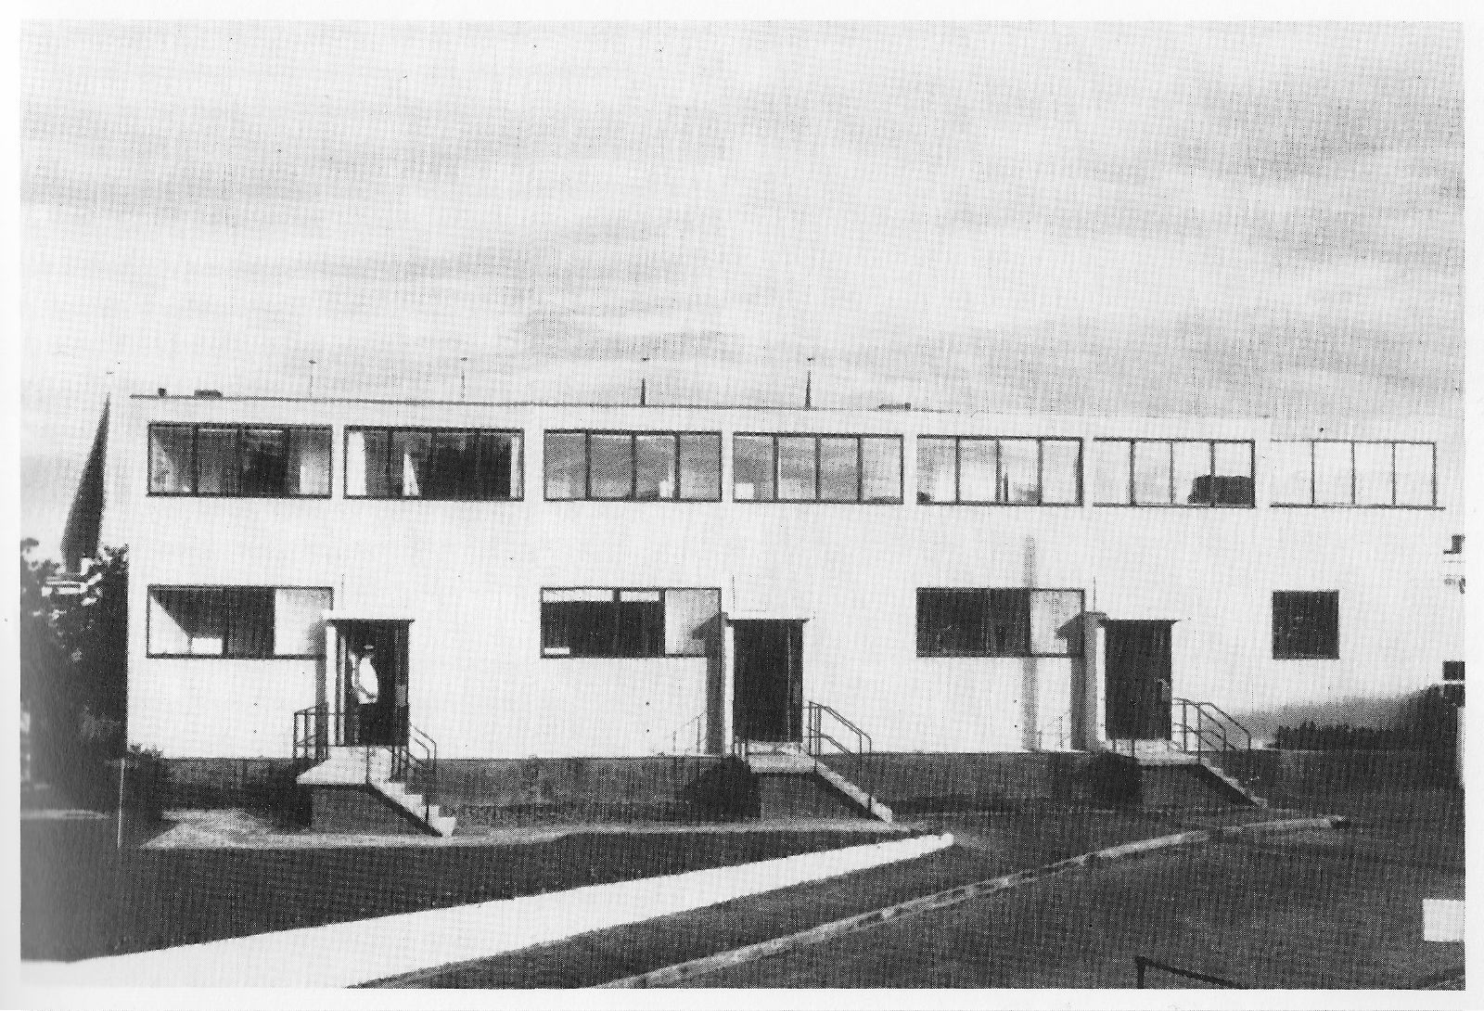
Fig. 1: Mart Stam, Houses 28-30. View from west, Stuttgart Weißenhof, 1927. Photograph: Stadtarchiv Stuttgart
Karin Kirsch, The Weißenhofsiedlung Experimental Housing built for the Deutscher Werkbund, Stuttgart 1927, Deutsche Verlags-Anstalt: Stuttgart, 1994, p.55.

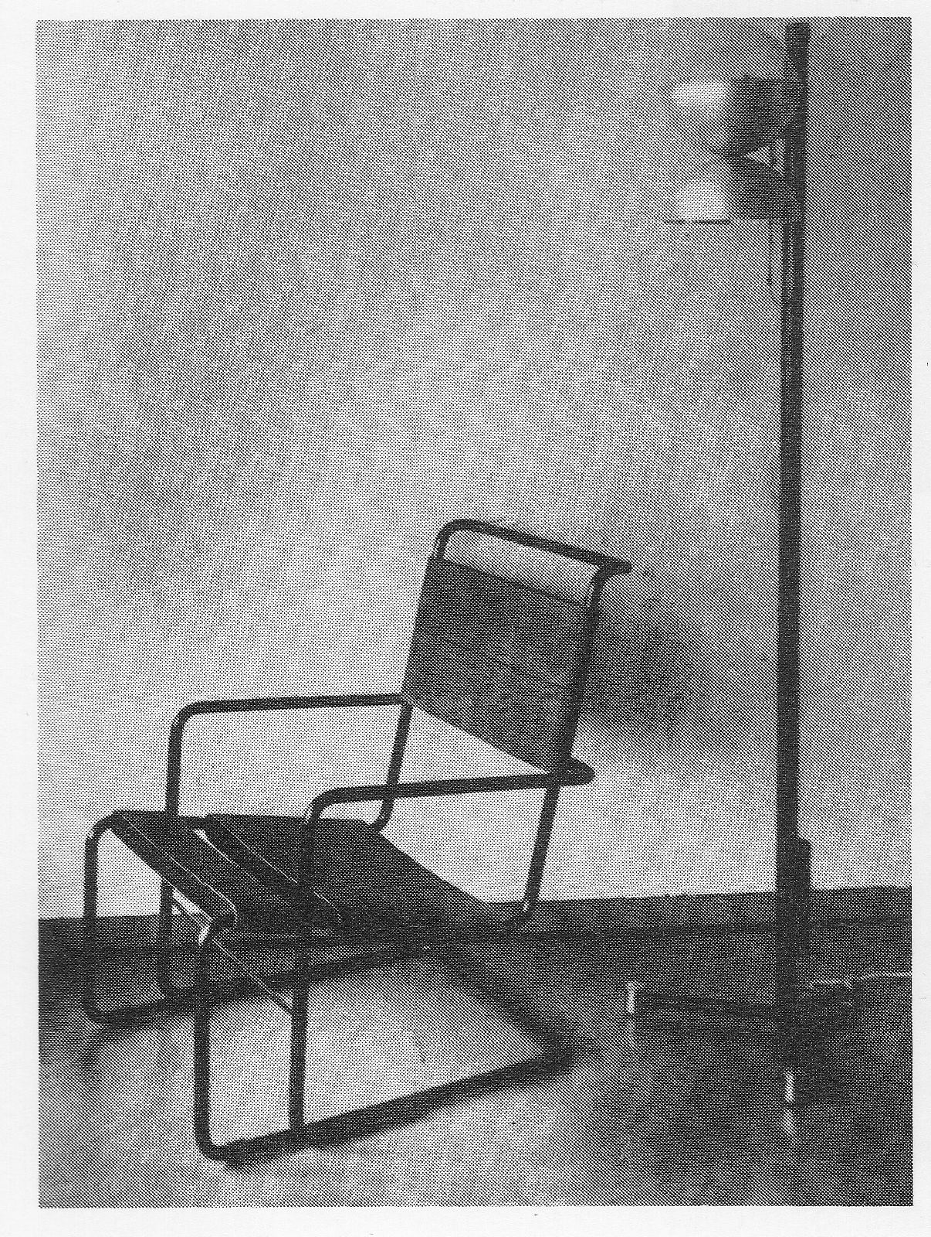
Fig. 2: Mart Stam, House 28: The “chair of the century”, Stuttgart Weißenhof, 1927. Photograph: Innenräume, Stuttgart, 1928.
Karin Kirsch, The Weißenhofsiedlung Experimental Housing built for the Deutscher Werkbund, Stuttgart 1927, Deutsche Verlags-Anstalt: Stuttgart, 1994, p.56.

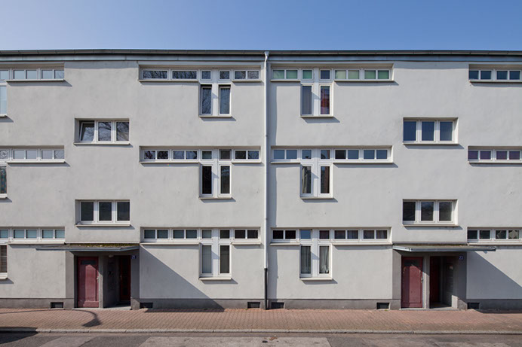
Fig. 3: Mart Stam, Hellerhof Settlement, street view, Frankfurt am Main, 1929.
© Matthias Matzak / VG Bildkunst

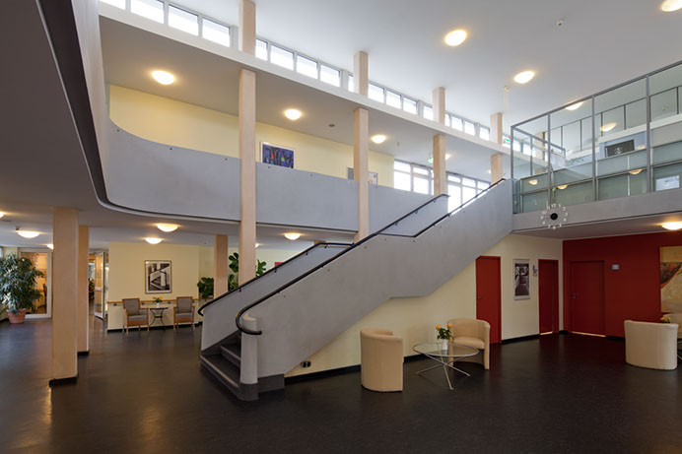
Fig. 4: Mart Stam, Werner Moser, Ferdinand Kramer, Henry and Emma Budge Old Peoples home, Frankfurt am Main, 1929-1930.
© Matthias Matzak / VG Bildkunst

